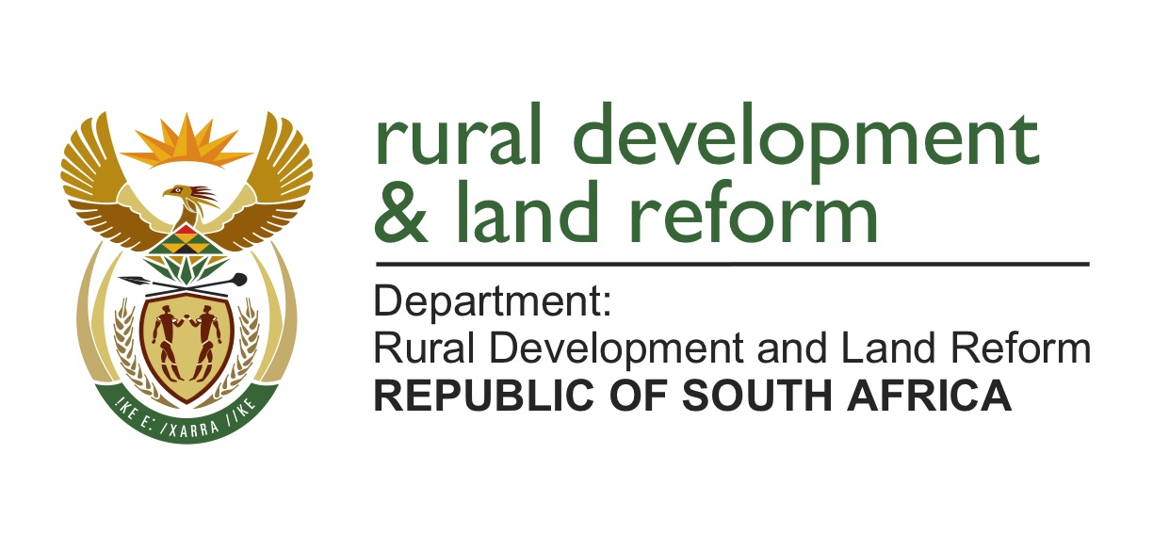
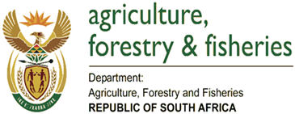

Office Use

Ref. no_____________________
(Start with 3 letters of name of province).

Private Bag X 250 Agriculture Place Pretoria 0001 20 Steve Biko Street Tel: +27(12) 319 6000 ARCADIA Fax: Pretoria Email: 0002

Website: www.DALRRD.gov.za

APPLICATION FORM
COVID-19 AGRICULTURAL DISASTER SUPPORT FUND FOR SMALLHOLDER AND COMMUNAL FARMERS
NB: Please use a black ink pen to complete this Application form.

- APPLICATION FORM SUBMISSION (FOR OFFICE USE ONLY)
Date of submission: |  | Submitted by:
Received by: |  | Signature :

- PERSONAL INFORMATION
Surname: | Names as appears in Identity Document (ID): |  | Gender:
 |  |  | Male
 |  |  | Female
Date of Birth: | Identity No:
*Race Group:  Please tick the applicable block | Black | White
 | Coloured | Indian
Home Address: | Postal Address: | Tel. No. (Home):  Cell No.:  E-mail:

- BUSINESS INFORMATION / INFORMATION ABOUT FARMING ACTIVITY
Name of Farm/Farmer/ Company/Business/ Traditional leader: |  |  |  | Name(s) of shareholders (if legal entity): |  |  |  |  | Registration number(s)  (if legal entity/ies):  Farm Number:  Farm Portion:  Farm Size:
Trust and registration no.:  (where applicable) |  |  |  | Trustee names and ID no (s): (where applicable)
No. of Dependants: (these should exclude workers / employees). |  |  |  |  | GPS Coordinates: | S
 |  |  |  |  |  | E
Farming Experience |  |  |  |  |  | Years
Type of farming: Provide information of the commodity you are farming with
Livestock:  Type:  Heads per Hectare:  Weaner weight:  Feed Conversion ratio:  Mortality rate: |  |  |  | Poultry:  Type:  Quantity :  Mortality rate: |  |  |  |  | Vegetables:  Type:  Hectares planted:  Dry land:  Irrigated land:  Yield per Hectare:
Winter Crops:  Type:  Hectares planted:  Dry Land:  Irrigated:  Yield per Hectare: |  |  |  | Fruits:  Type:  Hectares planted:  Dry Land:  Irrigated:  Yield per Hectare:
Province: |  |  |  | District: |  | Municipality: (include village and Ward no)
Does the applicant receive >80% of his/her income from this farming activity? | Yes |  |  | Is the farming activity’s annual turnover between R20,000 and R1 million? Please attach six (6) month’s bank statement. |  | Yes |  |  |  | State business annual turnover:
 | No |  |  |  |  | No
Farming activity’s annual turnover in words: (PS: if bank statement is not available, provide evidence of recorded sales)

Business Physical Address: |  |  | Business Postal Address: |  |  |  | Tel. No. (Business): (include area codes)  Fax. No. (Business): (include area codes)  Cell No.  E-mail:
Which of the following suppliers is closest to you? Boxer GWK NTK Cambridge Foods |  |  |  |  |  |  | Obaro Other:

- JOBS CREATED BY THE FARMING OPERATION
COMMODITY | PERMANENT JOBS |  |  |  | SEASONAL/ TEMPORARY |  |  |  | SHORT TERM
 | Male | Female | Youth | Disable | Male | Female | Youth | Disable | Male | Female | Youth | Disable

- WHAT ARE YOU APPLYING FOR?
- Provide summary description of the farming operation:

- Tick support required and provide details regarding quantities needed and for what size of farming:
  - Poultry: Day old chicks, Point of lay chickens, feed, medication and sawdust;

  - Vegetables: Seedlings, fertilizer, pesticides, herbicides and soil correction.

  - Fruits: Final spraying programmes for fruits that are ready for harvest.

  - Livestock: Feed and medication.

  - Winter field crops: Soil correction, fertilizer, seeds, herbicides and pesticides.

- Technical capability, please describe:

- Market and off take agreements (or letters of intent to be converted into offtake agreements); please describe:

- Technical support from provincial departments and other provincial organizations (commodity organisations); please describe:

- KEY RISKS AND MITIGATING STRATEGIES
- KEY RISKS IDENTIFIED

- MITIGATING STRATEGIES

- DECLARATION
I HEREBY DECLARE AND CONFIRM THAT I, AS THE PERSON/ENTITY/BODY/INDIVIDUAL/COMPANY WHO IS PROVIDING INFORMATION (HEREINAFTER COLLECTIVELY REFERRED TO AS THE “CLIENT”), DO HEREBY IRREVOCABLY AGREE AND UNDERSTAND THAT ANY/ALL INFORMATION SUPPLIED OR GIVEN TO DEPARTMENT OF AGRICULTURE, LAND REFORM AND RURAL DEVELOPMENT (DALRRD), IS PROVIDED IN ACCORDANCE WITH THE FOLLOWING TERMS AND CONDITIONS:
1. I certify that all the information provided and/or disclosures made to DALRRD are true and correct to the best of its knowledge. I understand that a false statement may disqualify me from any further consideration from DALRRD, without prejudice to any other rights or remedies available to DALRRD.
2. DALRRD collects, uses, processes (which shall include collecting, collating, storing and disclosing and retaining) and shares the provided information (with specific reference to personal information), to which I consent, for the purpose of the following:
a. Assessing and processing application
b Confirming and verifying an individual’s identity
c. Conducting market or customer satisfaction research
d. For audit and record keeping purposes
e. Register in government Farmer Register if not yet registered
This includes collecting and sharing the Client’s personal information with third party service providers who are essential to the credibility and affordability processes specifically or generally accepted as related to the Purpose.
3. I acknowledge that my personal information may be stored in a secure web-based facility, on behalf of DALRRD to ensure that my personal information is kept confidential at all times.
4. I acknowledge that I have the right to contact the DALRRD at any time to update, correct or delete its personal information.
5. I have the right to object to the processing of my Personal Information at any time and revoke any consent already given.
6. I hereby expressly agree that it is my own responsibility to ensure that I have read and understood these terms and conditions.
7. I do not have any conflict of interest that would make me ineligible for the COVID-19 Agricultural Disaster Support Fund. I am not employed by any organ of state as defined in section 239 of the Constitution.
8. I am not disqualified from applying for COVID-19 Agricultural Disaster Support Fund as per the applicable laws and regulations.
9. I undertake that I will use the implements and/or other inputs provided by DALRRD on my own farm and will not sell, dispose of and/or exchange with any other farmer and that any action to the contrary will bar me from getting any support from the DALRRD in the future, as well as entitle the DALRRD to recover the value of the support provided from me.
10. I understand and agree that upon signature of this application form by a duly authorised official of the DALRRD, this form becomes a binding agreement between myself and the DALRRD.
11. I confirm that I am the only member of my household at the listed address who is making application for the above funding.

Signed at ______________________________ on ____________________________________
Signature: _______________________________________________
Full name and surname: ____________________________________
Designation: _____________________________________________

8. FOR DALRRD USE - DECISIONS
APPROVED
YES
NO
or
FULL NAMES:_________________________________________________

DESIGNATION: ______________________________________________

AMOUNT APPROVED:__________________________________________

NAME OF SUPPLIER____________________________________________

SIGNATURE: _________________________________________________

